Pop ups in selenium: Whenever a particular window gets open over the screen once we perform action and it has options to perform the operation is called Pop up.

There are 2 types of pop up:

1. Alert pop up: A pop up which cannot be inspectable and it will not allow performing any action till user handles it.

To handle the alert pop we have to use alert() method.

Example to handle the alert popup:

**public** **static** **void** main(String[] args) **throws** InterruptedException {

System.*setProperty*("webdriver.chrome.driver", "E:\\desktop\\Katraj\\15 Jan\\Selenium\\chromedriver.exe");

WebDriver driver = **new** ChromeDriver();// chrome browser will get open

driver.manage().window().maximize();// to maximize the window

driver.get("https://chercher.tech/practice/practice-pop-ups-selenium-webdriver");

WebElement alertpopup = driver.findElement(By.*xpath*("//*[@name='alert']"));

alertpopup.click();

String textonalert = driver.switchTo().alert().getText();

System.***out***.println("Text on alert pop up is: " + textonalert);

// to handle the pop up we have to call alert() method

driver.switchTo().alert().accept();

// confirmation alert pop up:

driver.findElement(By.*xpath*("//*[@name='confirmation']")).click();

Thread.*sleep*(2000);

String confirmationstring = driver.switchTo().alert().getText();

System.***out***.println(confirmationstring);

driver.switchTo().alert().dismiss();

}

Assignment url for Alert popup:

<https://online.hrtchp.com/oprs-web/guest/home.do?h=1>

2. Child browser pop up: A pop up which comes over the screen with multiple options to perform the actions. It is also inspectable to find the locator and hence we can handle it.

Asssignment is to click on the close link over the pop up

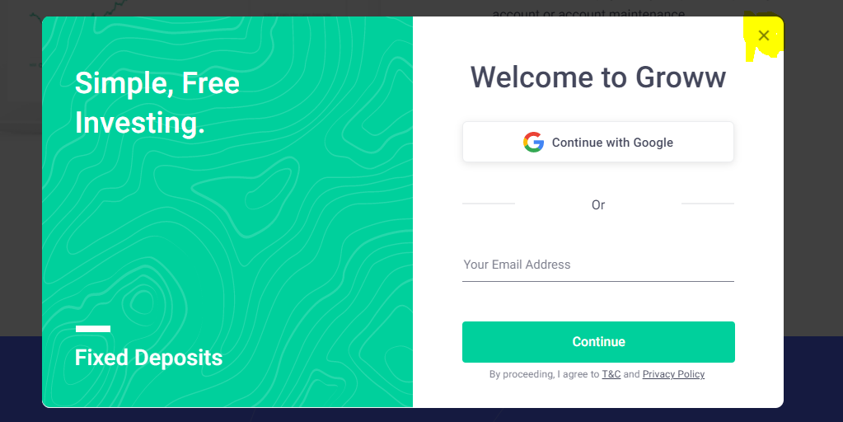

Example to handle child browser:

**public** **static** **void** main(String[] args) {

System.*setProperty*("webdriver.chrome.driver", "E:\\desktop\\Katraj\\15 Jan\\Selenium\\chromedriver.exe");

WebDriver driver = **new** ChromeDriver();// chrome browser will get open

driver.manage().window().maximize();// to maximize the window

driver.get("https://groww.in/");

driver.findElement(By.*xpath*("//*[@class='btn51Btn btn51RipplePrimary btn51Primary']//div//span[text()='Login/Register']")).click();

driver.findElement(By.*xpath*("//*[@id='login_email1']")).sendKeys("abc@abc.com");

driver.findElement(By.*xpath*("//*[@class='btn51Btn btn51RipplePrimary btn51Primary']//span[text()='Continue']")).click();

}